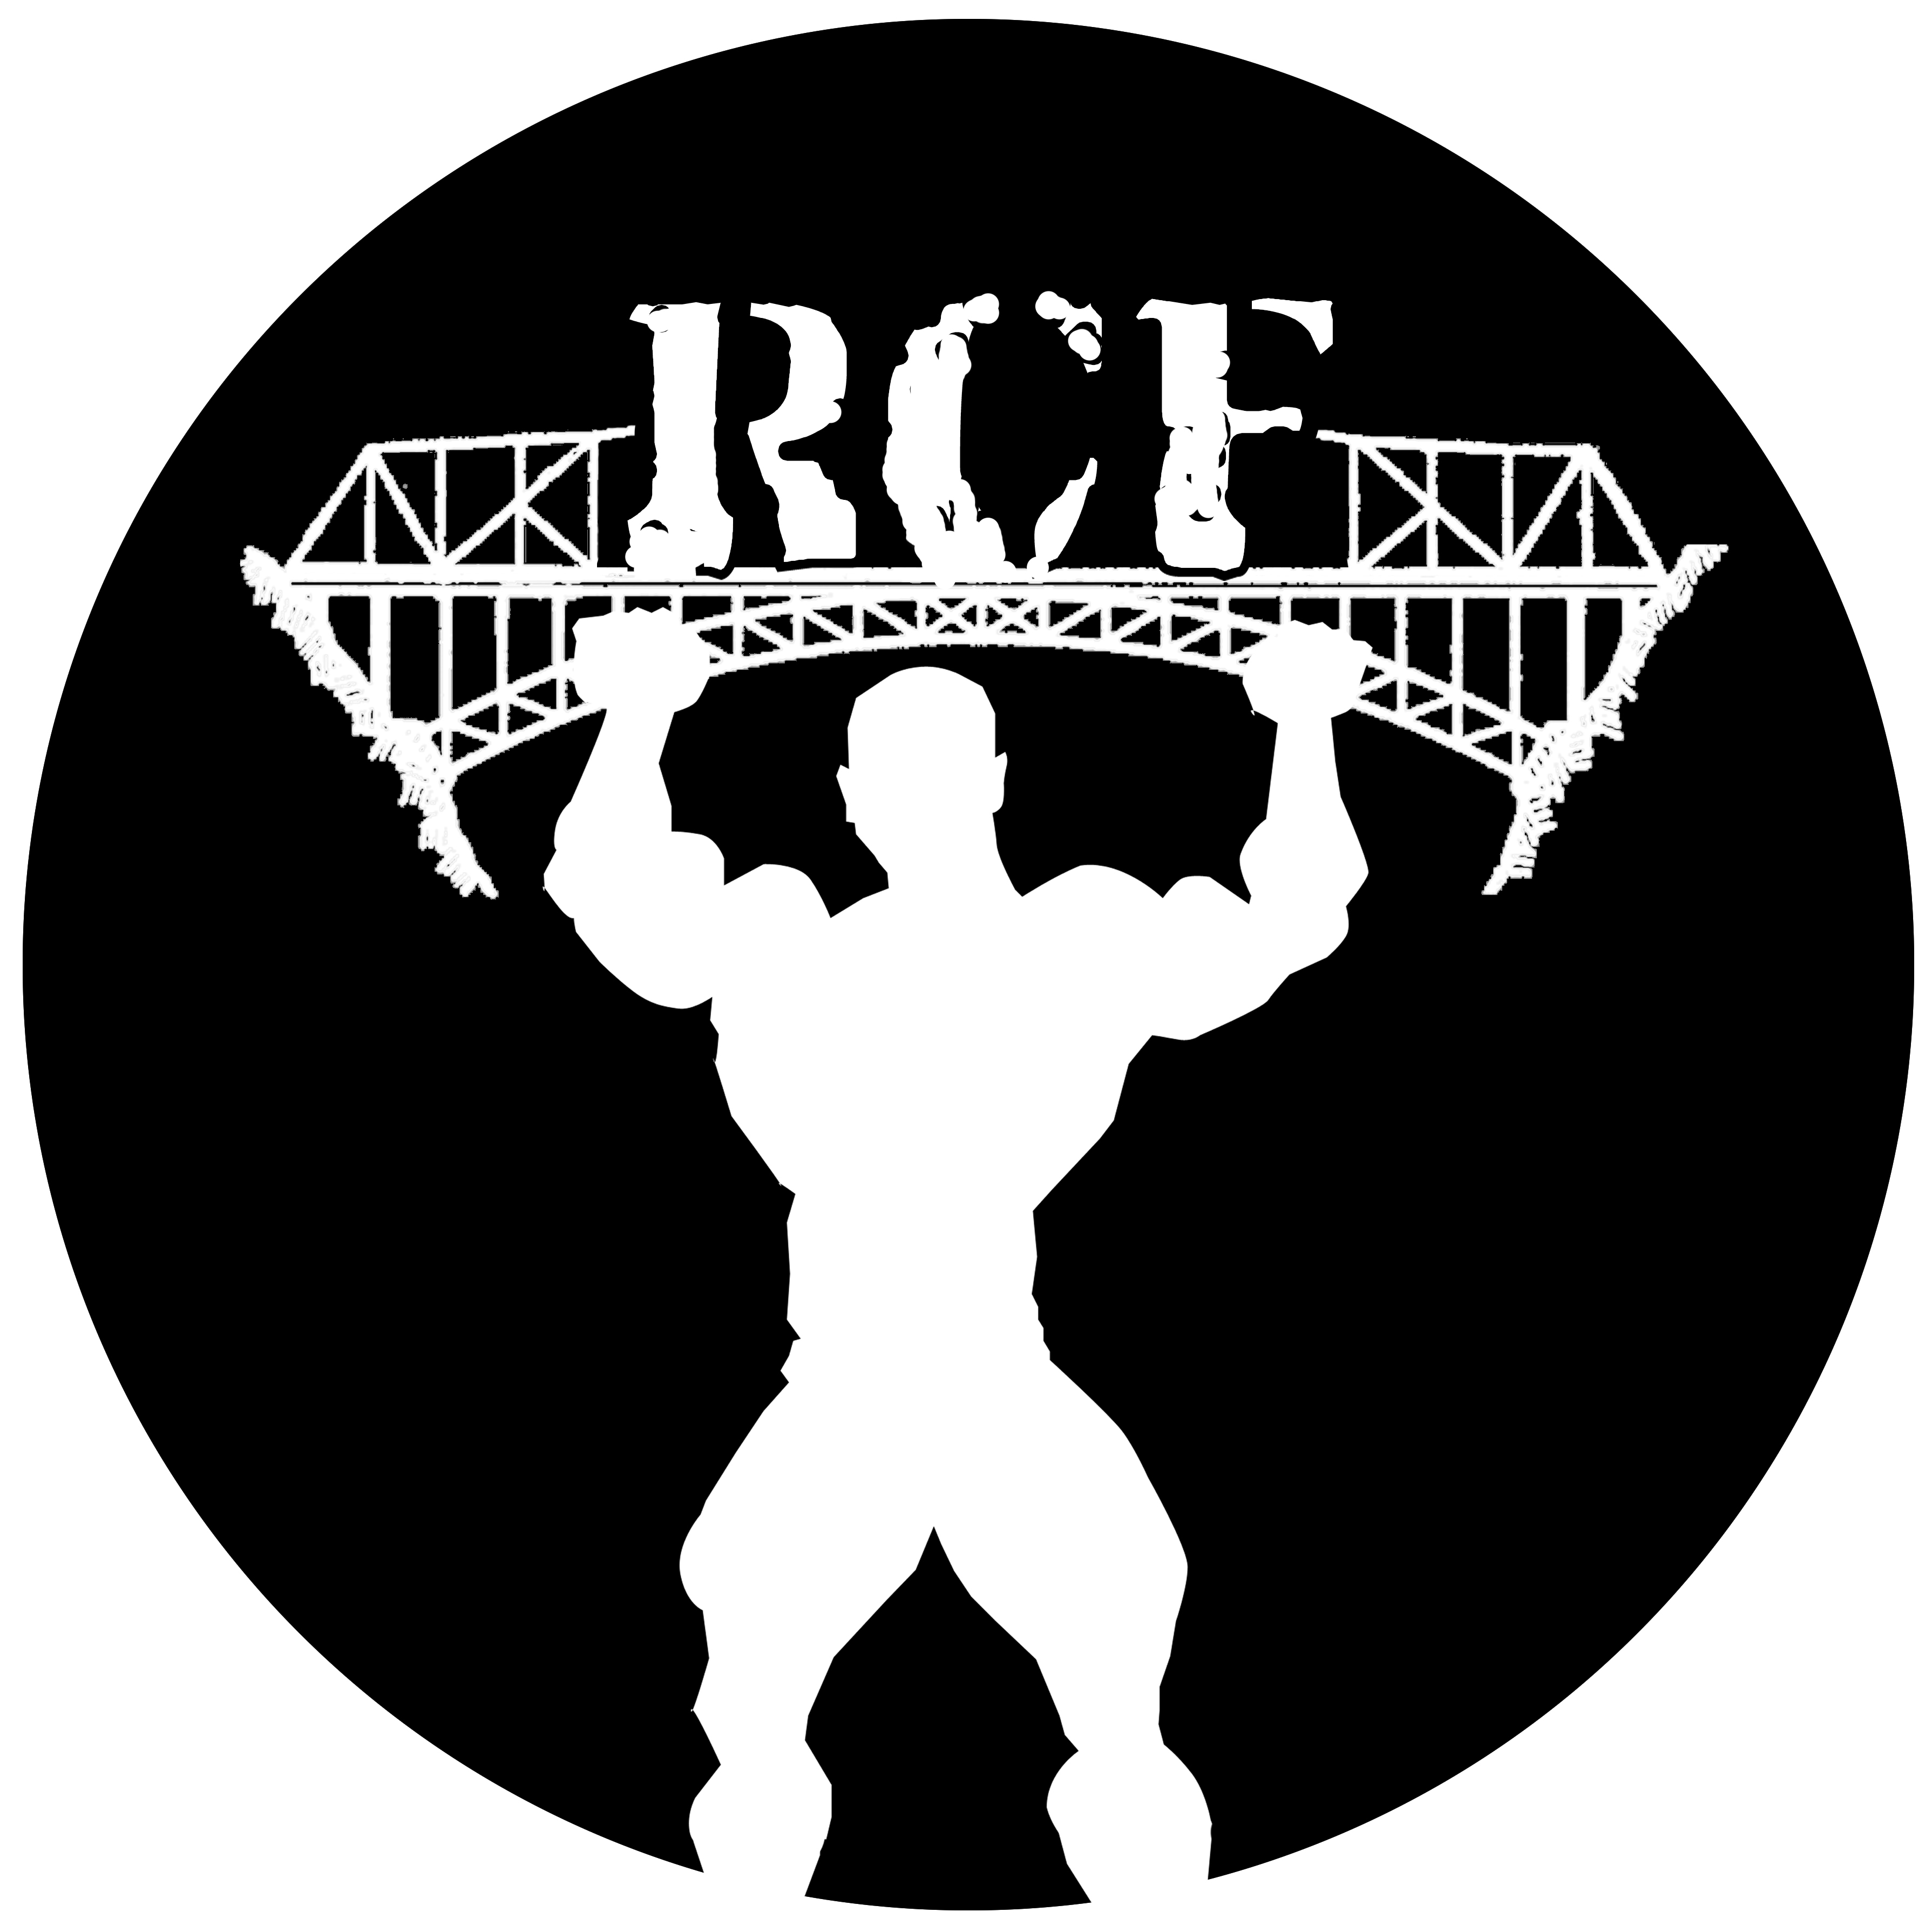
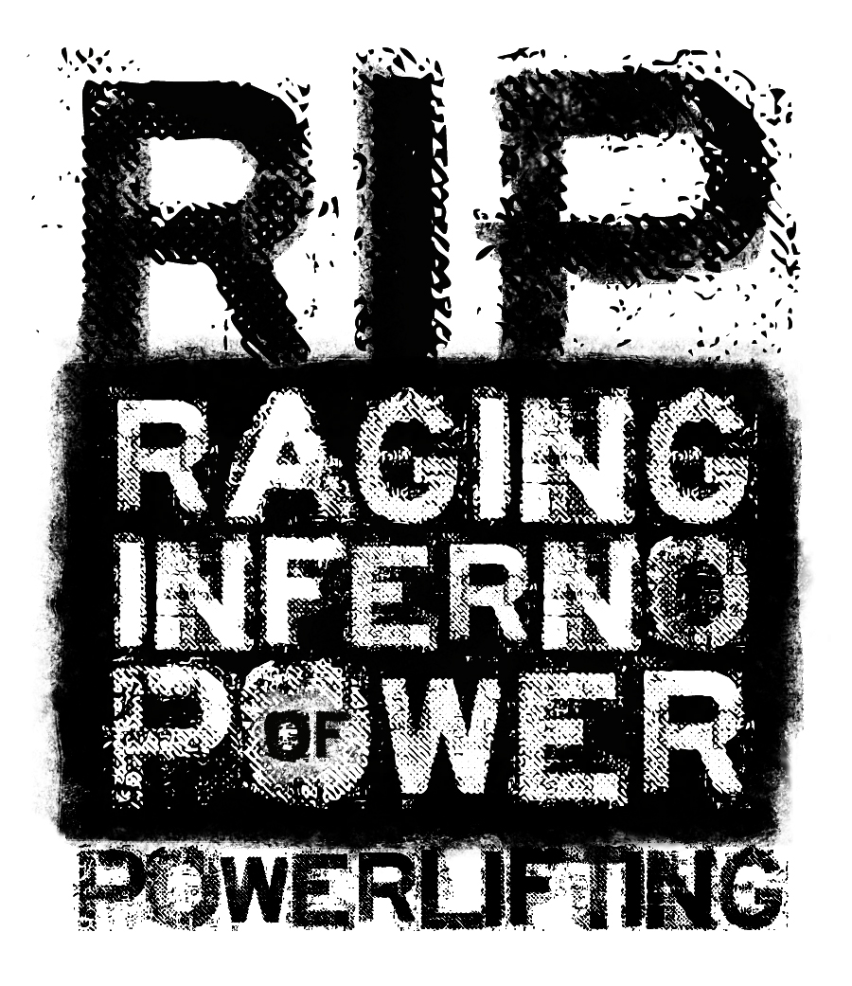
Raging Inferno Power
And River City Fitness

Present the

South Dakota APF/AAPF

State Powerlifting Championships

February 8, 2014

SPONSORED BY: RIVER CITY FITNESS, (605) 234-1018 RIVER CITY FITNESS, (605) 224-1425
Chamberlain, SD Pierre, SD

MEET DIRECTOR: J.R. Bolger, Meet Director
SD APF State Chairman
605-222-8640
powerlifter6662000@yahoo.com

SANCTIONED BY: The American Powerlifting Federation (APF)

PLACE: AmericInn® Lodge & Suites Chamberlain - Conference Center
Address: 1981 E King Ave, Chamberlain, SD 57325
Phone: (605) 734-0985
Room Fees: $64.99 if booked by January 8, 2014 (30 rooms blocked off)

ELIGIBILITY: Open to qualified APF registered athletes. All athletes must have a current APF registration card
or purchase one at the meet. Athletes may register at the meet or before weigh-in time with J.R. Bolger, State Chairman. (APF registration fee $30.00)
Make APF registration checks/money orders out to the APF, NOT THE MEET DIRECTOR

WEIGH-IN: Friday February 7, 2014 9:00 AM – 8:00 PM
Saturday February 8, 2014 7:00 AM – 8:00 AM

LIFTING SESSIONS: Saturday February 8, 2014 9:00 AM
Rules briefing will be at 8:00 AM

UNIFORM: Must have one piece lifting suit or wrestling suit. (Mandatory) Raw is belt and singlet ONLY

ENTRY FEE: All entry fees must accompany this entry form, to the meet director no later than January 8, 2014.
A late fee of $10 will be applied to all entries received POST MARKED after this date.

WEIGHT CLASSES: Men’s Open 114, 123, 132, 148, 165, 181, 198, 220, 242, 275, 308, and SHW
Women’s Open 97, 105, 114, 123, 132, 148, 165, 181, 198, and SHW
RAW division is for State Records ONLY

AWARDS: Awards will be given to the first three places in each men and women’s division. There will be “BEST LIFTER” awards as follows by formula:
APF – One Man and One Woman (The type of awards may vary, depending upon the number of entries)

ENTRY FORM

Name:
Last Name First Name MI

Residence:
Street city state zip

Telephone: E-mail address:

Date of Birth: APF CARD#

______Men’s Full Meet $75 Weight Class Age
______Women’s Full Meet $75 Weight Class Age
______Men’s Bench Press/Deadlift $65 Weight Class Age
______Men’s Bench Press $55 Weight Class Age
______Men’s Deadlift $55 Weight Class Age
______Women’s Bench Press/Deadlift $65 Weight Class Age
______Women’s Bench Press $55 Weight Class Age
______Women’s Deadlift $55 Weight Class Age

Meet DVD will be available for purchase (price to be determined)

Meet T-Shirts- $20 Size- S___ M___ L___ XL___2XL___3XL___

Total amount enclosed: $ ______

(ENTRY FEES AND CARDS FEES ARE TO BE PAID SEPARATELY, NOT TOGETHER)

AGREEMENT, WAIVER AND RELEASE

In consideration of the acceptance of this entry I hereby for myself, my heirs, executors, and administrators waive and release any and all rights and claims for damages I may have against the AmericInn, APF, River City Fitness, J.R. Bolger, their representatives, successors and assigns for any and all injuries or bodily harm that I might suffer while competing at the South Dakota APF/AAPF State Powerlifting Championships. I also agree that all pictures and video taken by the designated meet photographer may be used for advertisement and in sports publications.

Signature in full Date

Parent’s signature if under 18:

Make Meet Check Payable To: Mail Entry To:
J.R. Bolger J.R. Bolger
720 N. Oneida Ave.
Pierre, SD 57501

